1 run...

Downloading: 100%

411/411 [00:00<00:00, 5.64kB/s]

Downloading: 100%

263M/263M [00:11<00:00, 23.8MB/s]

training 1 epoch...

956.0357713699341 seconds used......

1 training finished! average train loss: 0.6345750140529629

evaluating...

Confusion matrix, without normalization

[[2305 0 235]

[ 192 0 95]

[ 402 0 1469]]

Normalized confusion matrix

[[0.90748031 0. 0.09251969]

[0.66898955 0. 0.33101045]

[0.21485836 0. 0.78514164]]

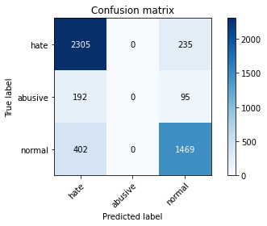

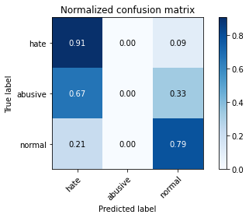

/opt/conda/lib/python3.7/site-packages/sklearn/metrics/_classification.py:1245: UndefinedMetricWarning: Precision and F-score are ill-defined and being set to 0.0 in labels with no predicted samples. Use `zero_division` parameter to control this behavior.

_warn_prf(average, modifier, msg_start, len(result))

/opt/conda/lib/python3.7/site-packages/sklearn/metrics/_classification.py:1245: UndefinedMetricWarning: Precision and F-score are ill-defined and being set to 0.0 in labels with no predicted samples. Use `zero_division` parameter to control this behavior.

_warn_prf(average, modifier, msg_start, len(result))

/opt/conda/lib/python3.7/site-packages/sklearn/metrics/_classification.py:1245: UndefinedMetricWarning: Precision and F-score are ill-defined and being set to 0.0 in labels with no predicted samples. Use `zero_division` parameter to control this behavior.

_warn_prf(average, modifier, msg_start, len(result))

precision recall f1-score support

hate 0.80 0.91 0.85 2540

abusive 0.00 0.00 0.00 287

normal 0.82 0.79 0.80 1871

accuracy 0.80 4698

macro avg 0.54 0.56 0.55 4698

weighted avg 0.76 0.80 0.78 4698

average eval_loss: 0.5135963941508151, accuracy: 0.8033205619412516

training 2 epoch...

956.1827547550201 seconds used......

2 training finished! average train loss: 0.49709965577265164

evaluating...

Confusion matrix, without normalization

[[2300 1 239]

[ 188 3 96]

[ 383 6 1482]]

Normalized confusion matrix

[[9.05511811e-01 3.93700787e-04 9.40944882e-02]

[6.55052265e-01 1.04529617e-02 3.34494774e-01]

[2.04703367e-01 3.20684126e-03 7.92089792e-01]]

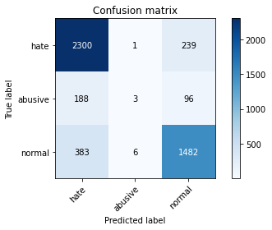

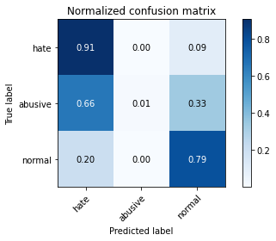

precision recall f1-score support

hate 0.80 0.91 0.85 2540

abusive 0.30 0.01 0.02 287

normal 0.82 0.79 0.80 1871

accuracy 0.81 4698

macro avg 0.64 0.57 0.56 4698

weighted avg 0.78 0.81 0.78 4698

average eval_loss: 0.5139038153151249, accuracy: 0.8056619838229033

training 3 epoch...

956.3289875984192 seconds used......

3 training finished! average train loss: 0.3398855521536625

evaluating...

Confusion matrix, without normalization

[[2241 56 243]

[ 158 22 107]

[ 356 58 1457]]

Normalized confusion matrix

[[0.88228346 0.02204724 0.09566929]

[0.55052265 0.07665505 0.3728223 ]

[0.19027258 0.03099947 0.77872795]]

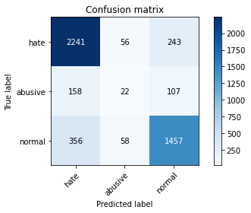

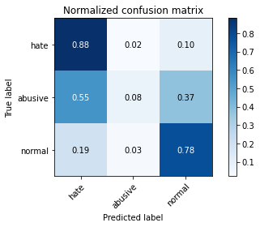

precision recall f1-score support

hate 0.81 0.88 0.85 2540

abusive 0.16 0.08 0.10 287

normal 0.81 0.78 0.79 1871

accuracy 0.79 4698

macro avg 0.59 0.58 0.58 4698

weighted avg 0.77 0.79 0.78 4698

average eval_loss: 0.5983916481758685, accuracy: 0.7918263090676884

training 4 epoch...

952.1549122333527 seconds used......

4 training finished! average train loss: 0.1981323881241019

evaluating...

Confusion matrix, without normalization

[[2172 40 328]

[ 148 16 123]

[ 333 38 1500]]

Normalized confusion matrix

[[0.85511811 0.01574803 0.12913386]

[0.51567944 0.05574913 0.42857143]

[0.17797969 0.02030999 0.80171032]]

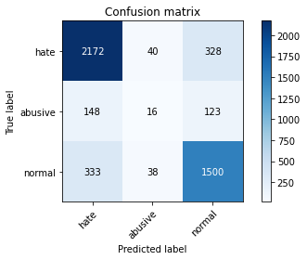

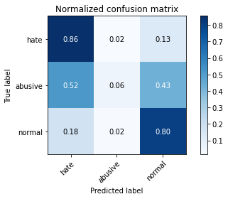

precision recall f1-score support

hate 0.82 0.86 0.84 2540

abusive 0.17 0.06 0.08 287

normal 0.77 0.80 0.78 1871

accuracy 0.79 4698

macro avg 0.59 0.57 0.57 4698

weighted avg 0.76 0.79 0.77 4698

average eval_loss: 0.8522469390738517, accuracy: 0.7850148999574287

training 5 epoch...

952.9470036029816 seconds used......

5 training finished! average train loss: 0.11522627787335214

evaluating...

Confusion matrix, without normalization

[[2250 100 190]

[ 165 50 72]

[ 394 151 1326]]

Normalized confusion matrix

[[0.88582677 0.03937008 0.07480315]

[0.57491289 0.17421603 0.25087108]

[0.21058258 0.08070551 0.70871192]]

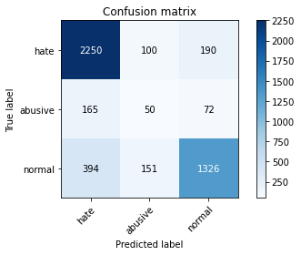

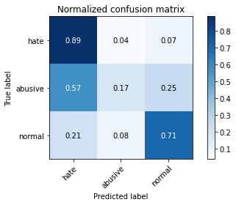

precision recall f1-score support

hate 0.80 0.89 0.84 2540

abusive 0.17 0.17 0.17 287

normal 0.84 0.71 0.77 1871

accuracy 0.77 4698

macro avg 0.60 0.59 0.59 4698

weighted avg 0.78 0.77 0.77 4698

average eval_loss: 1.0643033599599878, accuracy: 0.7718177948063005

2 run...

training 1 epoch...